**COMP4423 – Computer Vision**

**Assignment 2**

**Campus-tour Guide**

**[Deadline:** **23:59:00 Wen 29th March 2023]**

**1. Task Description**

Think of a scenario that a visitor is taking a campus tour at PolyU. It would be of a great help if there is APP which she can use to find information of on-campus landmarks. For example, she can take a photo of a building and the APP will recognize the building and return the information associated such as the name of the building and office locations. An example of such APPs is provided below for your reference.

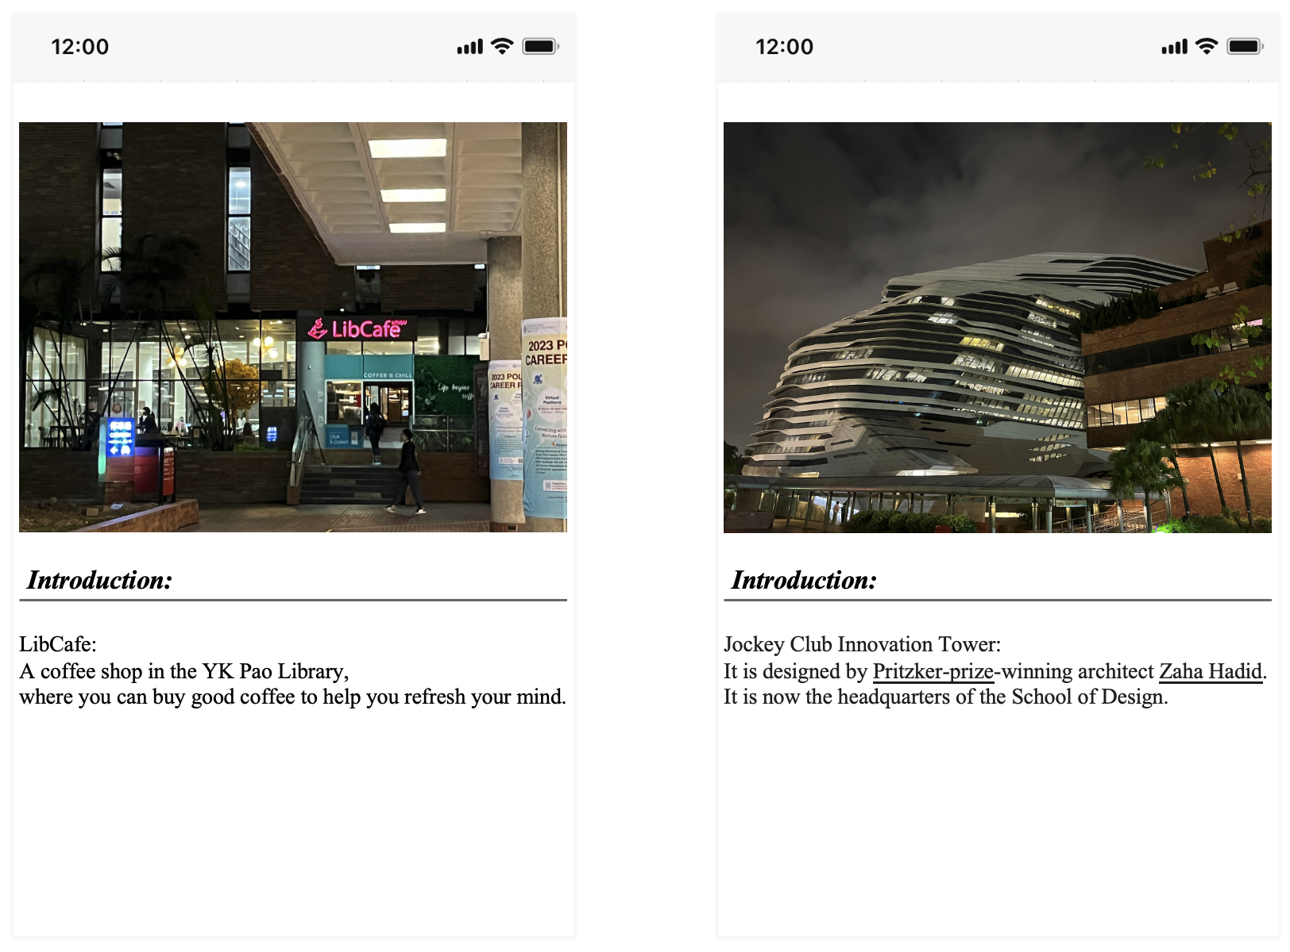

Your job is to develop an algorithm or model which can be used for building this APP. To this end, you may need to follow multiple steps such as collecting datasets, defining the framework (e.g., retrieval or detection), designing proper algorithms and validating their performance. You will also need to deploy and test the algorithm or model in a real scenario.

The task is open-ended, meaning you are free to develop any algorithm or model that works. Again, the focus is on practical experience rather than achieving a perfect result. It is encouraged to experiment with different models and pre/postprocessing techniques, even if they do not provide the desired outcome. You will also need to provide a detailed report outlining your step-by-step process for completing the task. This report should include your ideas, algorithm design, any problems encountered, and corresponding solutions, and findings you made during the project.

Note: You are not expected to build a complete APP. Instead, you are expected to focus on the development of the backend algorithm or model that makes the APP possible. However, in case you do manage to build a working APP, you will receive a bonus for your effort.

2. Tasks & Assessment

***Please submit a single .py file***

**Task 1 *Collecting the dataset*** (both images and textual descriptions). (**10 marks**)

**Task 2 *Defining this system as a proper CV task*** and ***giving reasons***. **(10 marks)**

**Task 3 *Designing corresponding algorithm*** for tour system and ***validating it***. **(20 marks)**

**Task 4** Implementing and testing the trained model in the ***real campus scenario*** (you can use the pictures we provide for testing or take pictures yourself). **(20 marks)**

**Task 5** A report to show the details of your method. Questions in the template should be answered. **(40 marks)**

**Bonus:** *Submissions with excellent code quality (including comment quality), output accuracy, and report quality or a working system will be given a bonus of no more than 10 marks (the final grade of this assignment will be ).*

3. Submission

Follow the steps below:

1. Name the .py file as Assignment2_<your_ID>_<your_name>.py.  
   *e.g.*, Assignment2_12345678d_CHAN_Dawen.py
2. Name the report as Assignment2_<your_ID>_<your_name>.pdf.

*e.g.*, Assignment2_12345678d_CHAN_Dawen.pdf

1. Compress the two files into a .zip file and rename the .zip file.

*e.g.*, Assignment2_12345678d_CHAN_Dawen.zip

1. Upload the .zip file to the blackboard system.

**Warning:  
If you are unable to complete the whole program, try to accomplish part of the tasks and make sure it can run successfully.**

**Any wrong file naming and submission will be given a ZERO mark in this assignment.**

The deadline for this assignment is **23:59:00 Wen 29th March 2023**.

**Late submission penalty**

10% is deducted for each day that the work is late. The penalty will be applied up to a maximum number of three days after and including the submission deadline day. After three days the work will be marked at zero.

**This assignment is individual work. All work must be done on your own. Plagiarism is a serious offence. Copying code from web resources is prohibited as well. Any plagiarism case (for both the copier and the copiee) will be given a ZERO mark in this assignment.**